**Week 1 Module 1.2 Assignment**

Juan Macias Vasquez

Bellevue University

CSD340-H323 Web Development with HTML and (2261-DD)

**Adam Bailey**

August 15th, 2025

Module 1.2 Assignment GitHub

GitHub Repository Link:

<https://github.com/Juan551School/csd-340>

<https://github.com/Juan551School/csd-340.git>

Screenshot of your local directory

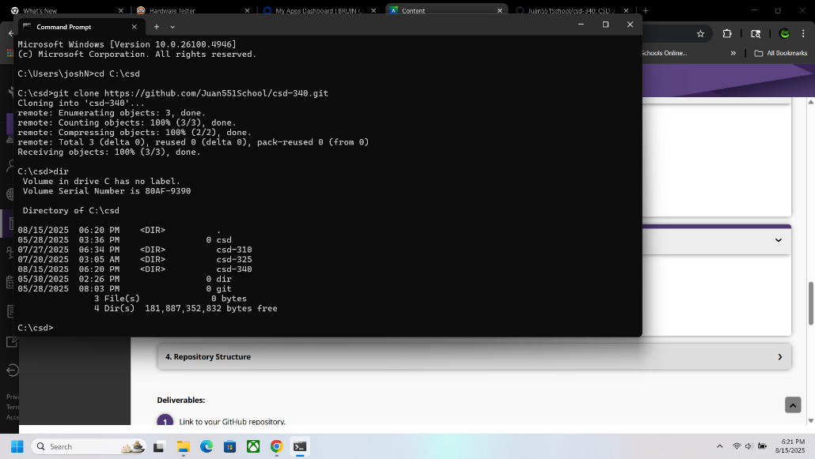

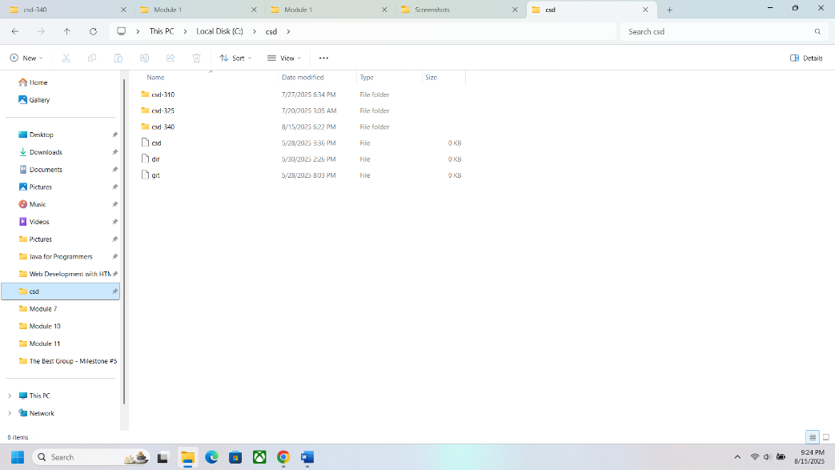

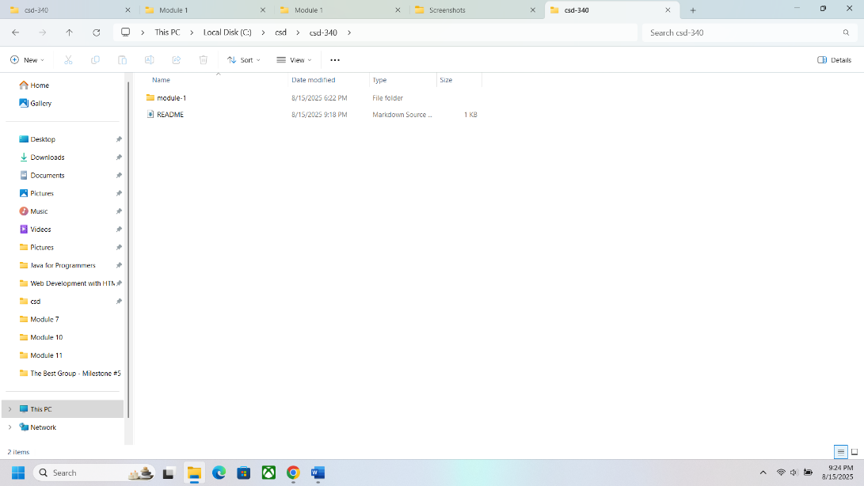

Screenshot of your GitHub repository

